**Report on**

**Interactive Meet with the Diplomatic Community**

**10th August 2015, Hotel Claridges, New Delhi**

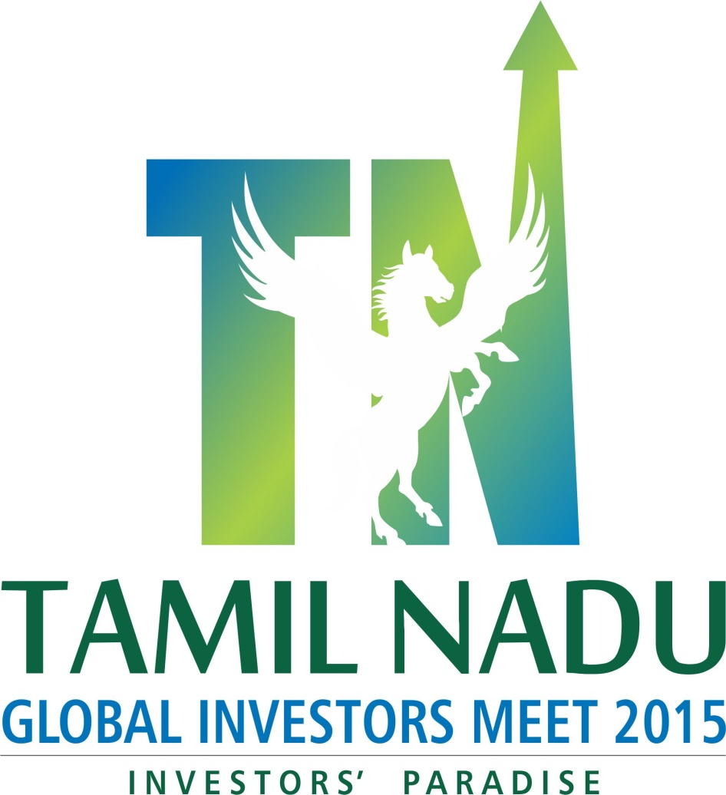

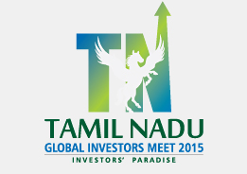

**Report on**

**Interactive Meet with the Diplomatic Community**

**10th August 2015, Hotel Claridges, New Delhi**

Tamil Nadu has witnessed a 7.8% Compounded Annual Growth Rate between the year 2007-08 and 2013-14, much higher than the national average and it is the second largest contributor to the Indian GDP. The State has a robust and diverse industrial base, impressive infrastructure and is one of the leaders in Human Development in the country.

Government of Tamil Nadu unveiled "Vision 2023" in 2012 which sets an ambitious target of making Tamil Nadu one of the top three investment destinations in Asia by 2023. It also envisages a growth of more than 11% over the next decade. The objectives are laudable and if achieved will certainly make the State one of the most prosperous regions in Asia. However, this would require and estimated infusion of funds of Rs 15, 00,000 crore, majority of which is expected to come from the private sector.

Apart from creating more congenial environment for the investors through policy measures, a dedicated and continuous investment promotion exercise is needed at the ground level to attract huge investments as envisaged in the document.

The Government of Tamil Nadu had an “Interactive Meet with the Diplomatic Community” on 10th August 2015 at Hotel Claridges, New Delhi to promote and Global Investors Meet 2015 organized by FICCI.

The objective being to reach out to all the Missions in India to promote TN GIM to tie up as Partner Country and to attract investor delegation to visit GIM 2015 in September 9th and 10th, 2015.

Mr. Arbind Prasad, Director General, FICCI welcomed the “diplomatic community” with his welcome remarks after which Thiru. C.V. Sankar, IAS, Additional Chief Secretary, Industries Department, Government of Tamil Nadu made a detailed presentation about the Global Investors Meet 2015. He concluded by inviting the Diplomats to visit the event in September and also to bring Business Delegations to enhance the business relationship between the Country and the State of Tamil Nadu.

Thiru Hans Raj Verma, I.A.S (Principal Secretary to Government), Department of Environment & Forest Department also spoke on the occasion welcoming the Diplomatic Community to promote GIM 2015 amongst their business community.

Earlier Dr. Vijay Pingale, IAS, Joint Secretary, Industries Department and Nodal Officer, Global Investors Meet make the presentation about the opportunities in 12 focus sectors and other details about the Event.

After a brief interaction with the participants Thiru. Jasper Singh Bajaj IAS, Resident Commissioner, TN House, Delhi proposed the Vote of Thanks. An exclusive “cultural evening” was performed by leading artist followed by Dinner.

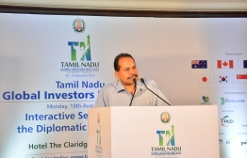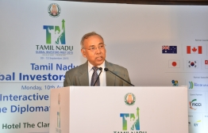 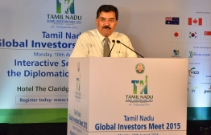

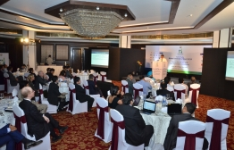

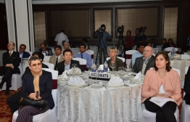

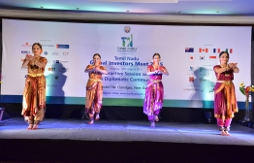

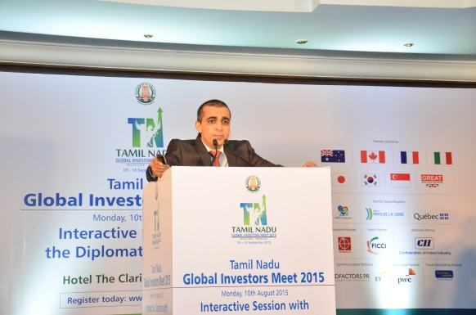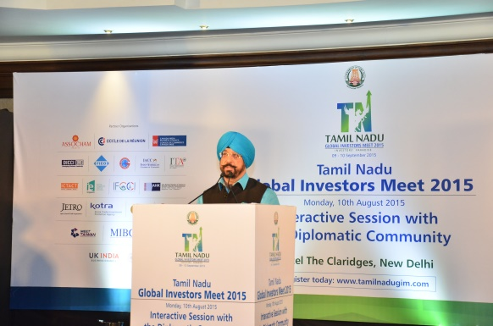

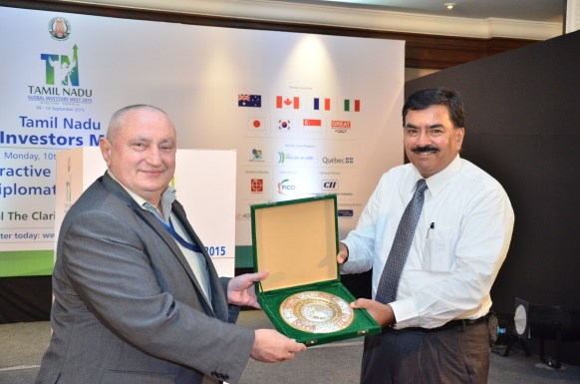

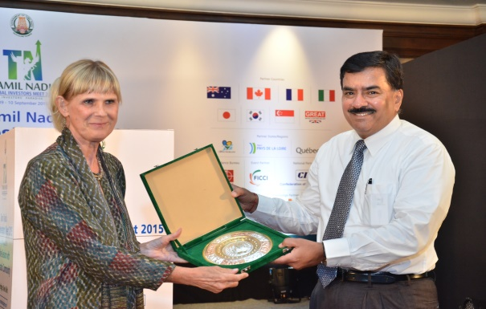

**Report on**

**Interactive Meet with Investment Bankers, Private Equity &**

**Venture Capitalist**

**06th August 2015, Hotel Trident, Mumbai**



**Report on**

**Interactive Meet with Investment Bankers, Private Equity &**

**Venture Capitalist**

**06th August 2015, Hotel Trident, Mumbai**

Tamil Nadu has witnessed a 7.8% Compounded Annual Growth Rate between the year 2007-08 and 2013-14, much higher than the national average and it is the second largest contributor to the Indian GDP. The State has a robust and diverse industrial base, impressive infrastructure and is one of the leaders in Human Development in the country.

Government of Tamil Nadu unveiled "Vision 2023" in 2012 which sets an ambitious target of making Tamil Nadu one of the top three investment destinations in Asia by 2023. It also envisages a growth of more than 11% over the next decade. The objectives are laudable and if achieved will certainly make the State one of the most prosperous regions in Asia. However, this would require and estimated infusion of funds of Rs 15, 00,000 crore, majority of which is expected to come from the private sector.

Apart from creating more congenial environment for the investors through policy measures, a dedicated and continuous investment promotion exercise is needed at the ground level to attract huge investments as envisaged in the document.

As Investment bankers act as a crucial link between prospective investors, Government and large corporations helping in conducting due diligence and identifying viable opportunities for investments.

The Government of Tamil Nadu had an “Interactive Meet with Investment Bankers, Private Equity &

Venture Capitalist 06th August 2015, Hotel Trident Mumbai to promote and Global Investors Meet 2015 organized by FICCI. The objective was to provide an overview about the Global Investors Meet, the initiatives of GoTN across various sectors and the opportunities available in each of those sectors.

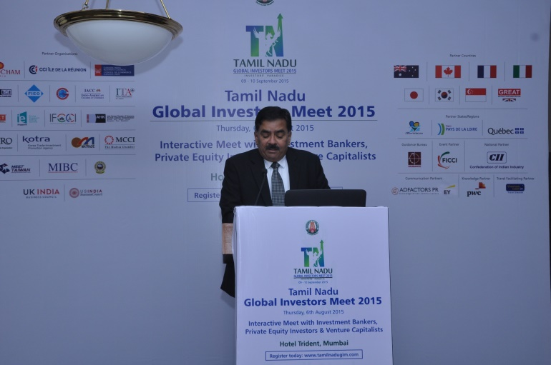Thiru. C.V. Sankar, IAS Additional Chief Secretary, Industries Department, Govt. of Tamil Nadu made a detailed presentation on the opportunities for the Investment Bankers during the Global Investors Meet and for their role in financing the industries. He encouraged them to visit and to interact with industry during this meet.

The meet was organized in two session exclusively for this sector one with the Investment Bankers and the other session with the Private Equity and Venture Capitalist at the same venue. There was very good response and more interaction with participants who were from leading names in the financially sector.

