 | 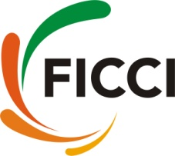

Workshop on “AgDSM: Adopting Technologies to Boost Efficiencies”

June 13, 2016
Commission Room, Third Floor, Federation House, FICCI,
Tansen Marg, New Delhi-110001

REGISTRATION PROFORMA

- Name of the Delegate: ______________________________________________________
- Designation: ______________________________________________________
- Organisation: ______________________________________________________
______________________________________________________
- Address: ______________________________________________________
______________________________________________________
City: ______________________ Pin: ____________________
- Phone No: ________________________ __ Fax: ____________________
- Email: __________________________ Mob: ____________________

Signature of the Delegate

Please return this response proforma to:

Ms Tavleen Kaur / Mr. Aryadipta Jena
Federation of Indian Chambers of Commerce and Industry
FICCI, Federation House,
1, Tansen Marg, New Delhi- 110001
Ph: +91-11-23487201
Fax: +91-11-23765333
Email: tavleen.kaur@ficci.com / aryadipta.jena@ficci.com

Note: This invitation is non-transferable and there are no registration fees.

