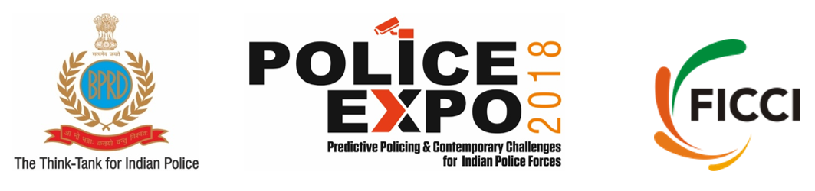
July 26-27, 2018
BPR&D Hqrs, Ministry of Home Affairs, NH-8, Mahipalpur, New Delhi

Exhibition Form
Company Name
Address
Tel:
Details of Contact Person
Title (Dr./ Mr./ Ms. etc.)
First Name
Last Name
Mobile
Tel
Email
FICCI Member (Y/N)

No. of Booth(s) required (Each booth is of 4 sq metres – 2 mtrs X 2 mtrs size)
☐ One ☐ Two ☐ Three ☐ More than Three, Pls specify Click or tap here to enter text.

Fascia Name in all capital letters (if you want FICCI to print)

Participation Charges

 |  | Indian Company (INR) | Foreign Company (USD)
1. | Bare Space (indoor) | 25,000/ sq metre | 425 / sq metre
2. | Built-up Space (indoor) | 30,000 / sq metre | 450 / sq metre
3. | Processing fee for PRODUCT FORM | 25,000 / form | 425 / form
4. | Delegate Passes/ Exhibitor Passes | Nil | Nil

Details required for raising Invoice

Company Name
Complete Address along with City, State, Pincode
GST Number (For Indian Companies)
Tax Number (For foreign companies)

Taxes
The aforesaid charges are exclusive of applicable taxes. The GST is 18%.
Forms
The Exhibiting Company is required to submit the following forms to FICCI along with the Exhibition Form:
- Product Form: It will be shared with the Screening Committee for evaluation. For multiple products you are requested to fill multiple forms.
- Form for Delegate/ Exhibitor Passes
- Form for Contractor Staff
Format of the Forms
We request you to submit only soft copy (Word File) of the forms to FICCI
Process of making payment
- After receiving your form along with company name, address and GST no., FICCI will raise an invoice.
- Thereafter, payment to be made through NEFT/ RTGS/ Cheque / Demand Draft drawn in favour of “FICCI”, Payable at New Delhi.
- FICCI bank account details will be mentioned on the invoice.

Standard Booth Details
- The octonorm exhibition stalls will be of 2mtr X 2 mtr X 8 feet (L X W X H)
- One standard 2 mtr X 2 mtr includes the following:
  - One Table
  - Two Chairs
  - Two Spot Lights
  - One Electric Point
- For any extra requirements, kindly intimate FICCI in advance.
- Posters or any other branding material could be pasted on the wall of the stalls but it could not be nailed.

Allocation of space
FICCI will have sole discretion in allocation of space. However, due consideration will be given to the choice and requirement of applicant (in case the same could be met).
Possession of Space
Possession to exhibitors taking bare space will be given after 11.30 a.m. on July 24, 2018. For exhibitors under shell scheme possession will be given after 10.30 a.m. on July 25, 2018. The handing over or possession in both cases will be subject to final payment of booth charges, fees, documents/ forms etc. to FICCI.
Handling of exhibits, customs and import
ATA Carnet
FICCI is India's sole National Issuing & Guaranteeing Association (NIGA) for ATA Carnet. For more details visit www.atacarnet.in
Completion of Stand
- Stands to be completed by 8 PM on July 25, 2018.

Operation of Stands
- No stand will remain unattended. All stands must open at least half an hour before the exhibition and shall remain open till half an hour after exhibition time on each day.

Storage of exhibits & empties
No exhibits or empties will be stored behind the exhibition stands.
Vacation of space
Stands will have to be vacated under ‘shell scheme’ and ‘bare space’ latest by 4PM on July 28, 2018.
Damages to the hall
Exhibitors will be required to make good all damages or make payment for damages in the Halls, if any.
Sale of exhibits
No counter sales will be permitted during the exhibition.
Service Agencies
Service agencies like security, cleaning, phones, catering, courier etc. empaneled with FICCI will only be allowed to provide services to exhibitors. Other agencies will not be allowed to enter/operate in the exhibition.
Insurance
Against all ascertainable risks from transportation to display and removal should be done by exhibitor. FICCI will not be responsible for any claim.
Entry/Exit
Entry into “BPR&D Hqr, Ministry of Home Affairs, Mahipalpur, New Delhi’ will be on the basis of exhibitor passes issued by FICCI. Entry of vehicles at the Venue will not be permitted during exhibition hours and other hours specified separately. Exit passes will be necessary for exhibits / material to be taken out of venue.
Violation of Rules
In the event of violation of any rules, FICCI will have the right to close down the stall of the exhibitor.
Disputes
Disputes, if any, arising out of unresolved matters between exhibitor and FICCI shall be settled by arbitration in accordance with the Arbitration and Conciliation Act 1996. The arbitration proceedings will be conducted in English and at New Delhi, India only.

Force Majeure

If the exhibition is abandoned, cancelled or suspended in whole or in part by reasons of war, fire, national emergency, labour, non-availability of exhibition premises or any other cause not within the control of FICCI. FICCI may, at its own discretion, refund the rental paid by the exhibitor after adjusting the basic expenses incurred or a part thereof, but FICCI shall be under no obligation to refund any such rental and part thereof and shall be under no liability for any actions, claims or losses.

For further details contact:
Ms. Komal
E: homelandsecurity@ficci.com
M: +91-99586 07238

