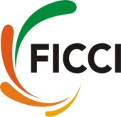

FICCI Defence & Aerospace Industry Delegation to Farnborough International Airshow 2018
16-22 July 2018: Farnborough, UK

FICCI has successfully lead the Defence & Aerospace Indian Industry Delegation to Farnborough International Airshow (FIA) 2018 at Farnborough, United Kingdom during 16-22 July 2018.
FIA 2018 is the global shop window for the UK and international aerospace industry. FIA is a biannual show and perfect platform to meet with clients & suppliers from the world’s aerospace industry. It brings together manufacturers, supply chains & MRO companies at one platform. FIA was globally-attended with nearly 100 countries represented and an unprecedented number of military & civil commercial delegations along with global industry leader and government representatives from around the world. The Farnborough International Airshow connects an industry worth $350bn.
FIA has helped the FICCI A & D delegation members to meet potential business partners across the globe at single platform through B2B meetings.
Key Highlights
- Delegation members had business meetings with Lockheed Martin, BAE Systems, Terma, Airbus, Aubert & Duval, Boeing, Thales, Bombardier, SAAB and GKN Aerospace. Business to Business interaction with these companies senior representative helped to understand their requirements and procedures to become part of their global supply chain. Indian companies has also briefed about their capabilities in defence & aerospace manufacturing and services areas. Discussions focused on possibilities of mutual cooperation and explore the business opportunities jointly. Foreign OEMs expressed their interest to work with delegation companies and assured them to be added in their global supply chain.
- Delegation had visits to Country pavilions like Brazil, UK, Portugal, Canada, Czech, France, US, Netherland and Austria. Focussed B2B meetings/interactions with heads of Global Aerospace companies from respective countries. Meeting with select companies from country pavilions was fruitful and provides good networking opportunities. Emphasis was given on companies to have business tie ups with Indian Companies to expand their business in India and take part in Make in India for co-production & co development in India along with global export markets.
- Had meeting with Mr David Woolf, DSO, Department for International Trade (Defence & Aerospace Sector) British High Commission in India. He has encouraged the Indian companies to do more business with UK companies. Business opportunities with India-UK companies will help both countries to have strategic tie ups. Also many UK companies are willing to enter Indian market. They will be looking for local partners in India.
- Panel Discussion & Briefing on ‘Access India Programme’ initiative formed under the Government of India’s ‘Make in India’ initiative. Session organised by Indian High Commission in UK. Mr Manish Singh, Minister Economic, High Commission of India in UK addressed the delegation members that we are encouraging and assisting UK companies to help them to do business in India. His office is providing full assistance. Further agencies like FICCI and Invest India will be of great help to UK investor for setting up base and finding right partner in India.
- MoU signing between idD - Portuguese Platform for Defence Industries, Portugal & FICCI - Federation of Indian Chambers of Commerce and Industry, India in the presence of Secretary of Defence, Portugal in the presence of Mr Eurico Brilhante Dias, Secretary of State for International Affairs, Republic of Portugal. Companies from India & Portugal has introduced themselves and explore possibilities for tie ups. IdD has requested to bring the Indian Industry delegation to Portugal in Nov/Dec 2018. Embassy of India in Portugal has also confirmed its full support to the proposed delegation to Portugal.
- MoU signing between Maharashtra Airport Development Company Ltd & GKN Aerospace for setting up manufacturing plant in Nagpur.
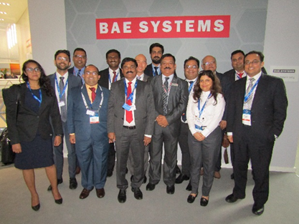  Delegation members visited BAE Systems chalet at Farnborough Air Show | 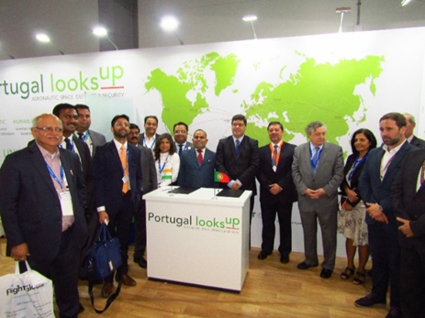  Delegation members at Portugal Pavilion after signing of MoU between IdD and FICCI in the presence of Mr Eurico Brilhante Dias, Secretary of State for International Affairs, Republic of Portugal & Mr Henrique Castanheira Macedo, President & CEO, IdD Portugal.
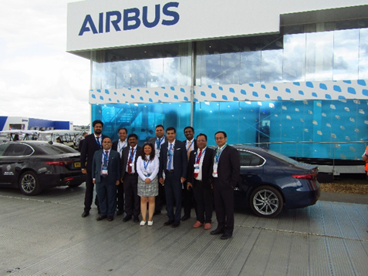  Delegation members after meeting at AIRBUS Chalet. | 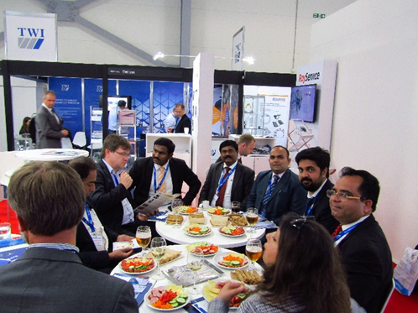  Delegation members having meeting with Mr Petr Ocko, Deputy Minister, Ministry of Industry & Trade, Czech Republic
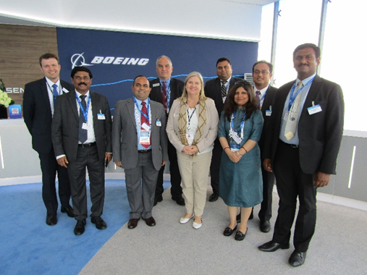  Delegation members after meeting BOEING | 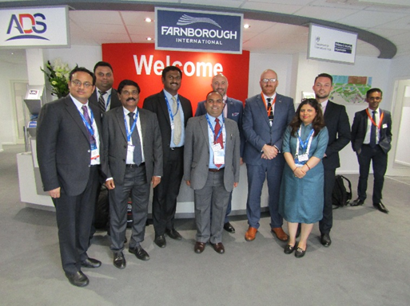  Delegation members after meeting with Mr David Woolf, DSO, British High Commission in India
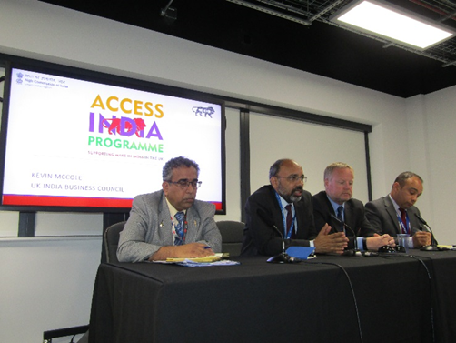
Mr Manish Singh, Minister Economic, High Commission of India in UK address during session on Access India. Other panellist’s members are from HAL, BAE Systems and Rolls Royce.

Compilation of FICCI Indian Defence & Aerospace Delegation
S.No | Title | Name | Surname | Designation | Organisation
1 | Mr | Alok N | Sinha | Director | Alar Impex Pvt Ltd
2 | Mr | Deepak | Sebastian | CEO | Amado Tools
3 | Mr | Vaibhav | Vohra | Managing Director | Continental Carriers Private Limited
4 | Mr | Sonu | Arora | Director | E C Blades & Tools Pvt. Ltd.
5 | Mr | Sukhdeep | Singh | Vice President Marketing | E C Blades & Tools Pvt. Ltd.
6 | Ms | Vandana | Das | Executive Director | Inext Logistics & Supply Chain Private Limited
7 | Mr | Amardeep | Singh | Managing Director | Inext Logistics & Supply Chain Pvt Ltd
8 | Mr | Nishanth | Ramesh | Director Operations | Metallic Bellows India Pvt Ltd
9 | Mr | Suhas | D S | Head-Business Development | SLN Technologies Pvt. Ltd
10 | Mr | Somendra | Gautam | Senior Assistant Director ( Defence & Aerospace ) | Federation of Indian Chambers of Commerce and Industry, FICCI

