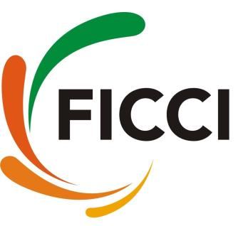

Workshop on
“Secret of Peak Performance”
0930 hrs: 20 December 2023: Hotel Ramada, Govind Marg, Raja Park, Jaipur

REGISTRATION FORM

Organization:
GST Number:
Address:
Nominating Authority Name & Designation:
Phone & Mobile:

We are pleased to nominate the following:

S. No. | Name | Designation | Mobile Number | Email ID
1
2
3
4

Participation Fee:
- Rs 3,000 + GST per delegate for FICCI Members, Govt Organizations, PSUs and Academic Institutions
- Rs 4,000 + GST per delegate for Non-Members

Please note:
- Bulk nomination discount of 10% would be applicable on the nomination of 3 or more delegates.
- Due to limited seats participation is only through prior registration on a first come first serve basis.
- Programme is non-residential and the delegate fee is non-refundable however change in nomination is acceptable.

DD/ Cheques to made in Favour of 'FICCI' at par Jaipur | RTGS/ Transfer Bank Details
GST No: 08AAACF1282E1ZZ  PAN No: AAACF1282E | Bank Name: ICICI BANK LTD  A/c No: 678601701103  Branch: Tilak Marg, C-Scheme, Jaipur  IFSC Code: ICIC0006786

Please send the dully filled registration form along with Cheque / DD or payment details to:

Dimple Vij  FICCI Rajasthan State Council  202, Gravita Tower, A-27-B, Shanti Path  Tilak Nagar, Jaipur – 302 004 | Mob: +91 85275 87757  Phone: +91 141 2621345 / 4061345  E-mail: events.rajasthan@ficci.com

